Assignment #2 – Business 100
Name:

Background information needed to answer Question #1:

Review Shaun's criteria below to determine the best financing option to expand his business:

SHAUN’S CRITERIA

Hi Team,

I wanted to provide you some guidelines as you determine how we’ll finance our expansion. Please give this careful consideration, as we need to get this right.

- I estimate we’ll need $150,000 to increase capacity in order to stock the five additional pop-up stands
- We’ll need to make sure we have additional funds available to increase our marketing efforts to stimulate demand
- Cash flow is going to be tight, so I’d like to minimize interest payments
- I’d like to maintain or increase our profit margins
- Since I don’t have a lot of experience with big discount retailers, I’d like to add a thought partner with experience in this channel
- If we’re successful over the next two years, we’ll likely seek additional capital to expand into more stores, so I’d like to do all we can now to enhance our credibility
We need to move on this quickly, so I’d like an answer by the end of the week.
-Shaun

FINANCING OPTIONS
As we have learned, there are pros and cons to all financing methods which of the three financing methods would be the best fit based on Shaun's criteria above?

Option 1: Equity
Raise $150,000 from a venture capital firm in exchange for 30% of the company

Option 2: Debt
Secure a loan of $150,000 at a 10% annual interest rate, to be repaid over 7 years

Option 3: Debt + Self-Financing
Secure a loan of $100,000 at a 7% annual interest rate, to be repaid over 7 years, and self- finance the remaining $50,000

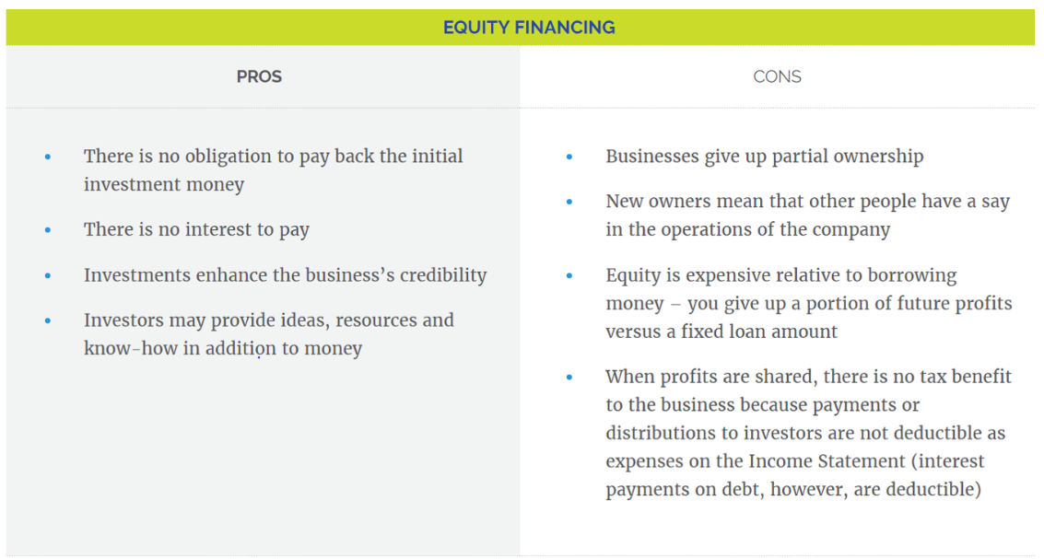
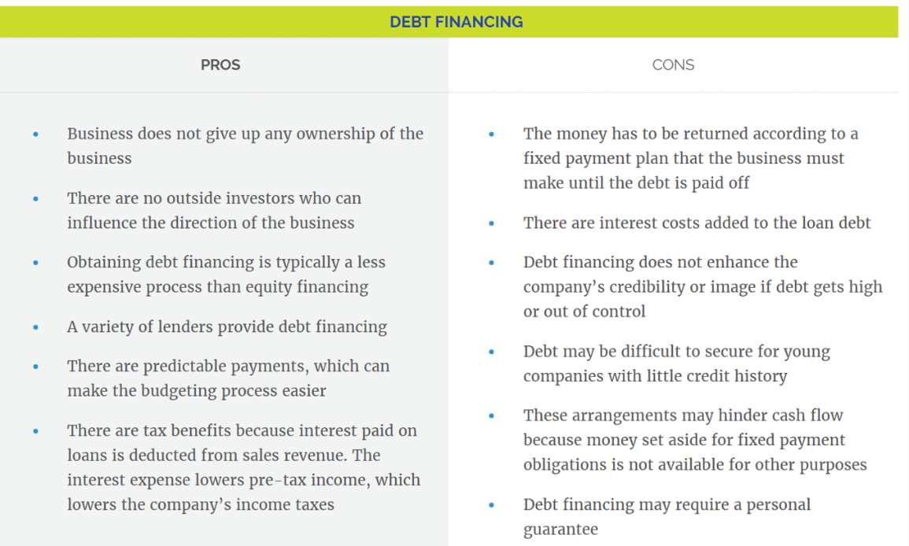
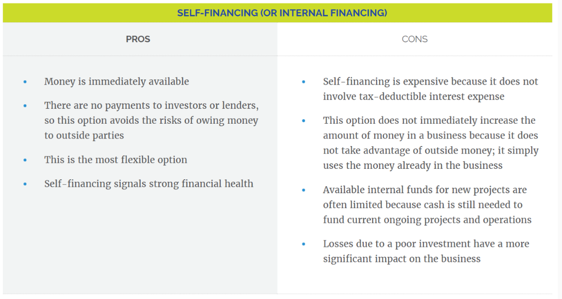
Question 1:
Based on your analysis of the owner's wishes (Shaun's criteria) and the three financing options available, which financing option would be the best option?

- Option 1: Equity
- Option 2: Debt
- Option 3: Debt & Self Financing

Include your answer your response below and also explain why you selected that type of financing based on Shaun's criteria and what you know about that financing option.

Background information needed to answer Question #2:

A junior accountant is working to get everything in order for the new financing and has come to you with a question about what do next in the accounting cycle. Read this email from the junior accountant so you can determine what steps of the accounting cycle she has already completed and what is the next step to complete.

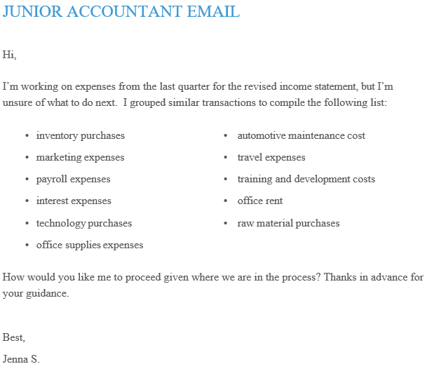
As a refresher, here are the 5 Steps to the Accounting Cycle:
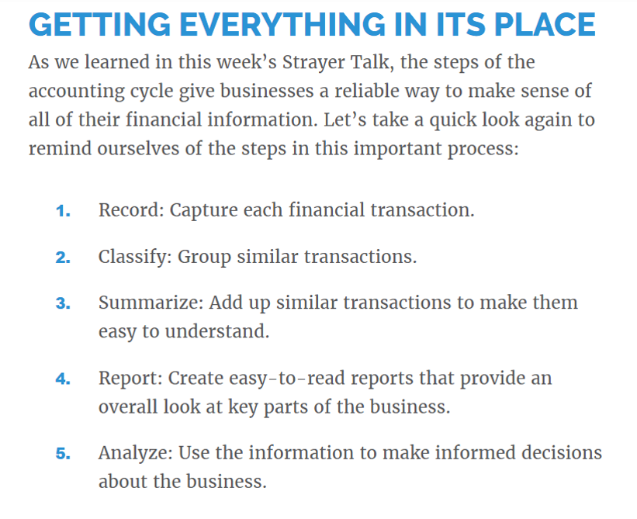

Question #2:

So, given what the Junior Accountant has done so far, what is the next step for the Junior Accountant to complete in the Accounting Cycle and why?

Background information needed to answer Question #3:

A potential investor has been identified, but before they are willing to commit, they have requested information about SunsTruck’s current debt from the junior accountants. You have been charged with reviewing the financial statements (found in the resources) and providing direction to the junior accountant to comply with the request from the potential investor:

Identify the correct financial statement for your junior accountants that will provide the investor with the information it has requested.

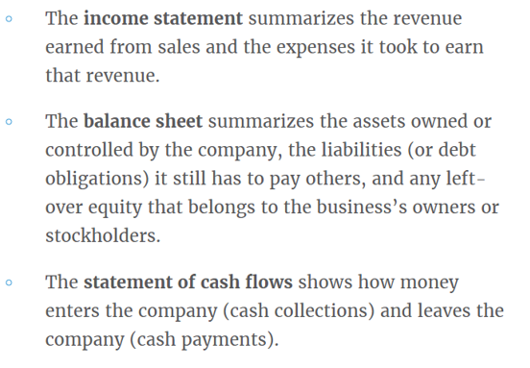

Question #3:

After reviewing the 3 Financial Statements, please indicate which financial statement (pick one: income statement, balance sheet, or statement of cash flows) the Junior Accountant should provide the investor in order to show the debt information.

- Income Statement
- Balance Sheet
- Statement of Cash Flows

Explain where on that financial statement you would find the debt information.

Next step: submit your work
- Save this document to your desktop
  - Navigation: select file at the top, save as – select desktop, and select save
- Log into your class and select Assignment #2 on the left, scroll down and select “submit your work”, click browser my computer, find your file on the desktop, click open, then click submit.
- If you have any issues email me or call me.
I will provide you assignment feedback and you can then make any changes you would like and resubmit for grading.
Congrats on completing assignment #2!

